14-2_SQL_Trushkova_PRIMARY_KEY_ FOREIGN_KEY_CHECK

Allows a foreign key row that is referenced to a primary key row to be deleted- ON DELETE CASCADE

Explicitly defines a condition that must be met- Check Constraint

A column or set of columns that uniquely identifies each row in a table- PRIMARY KEY

Constraint ensures that the column contains no null values-NOT NULL

Allows a child row to remain in a table with null values when a parent record has been deleted-ON DELETE SET NULL

Establishes a relationship between the foreign key column and a primary key or unique key in the same table or a different table-FOREIGN KEY Constraint

1.  What is the purpose of a

a.  PRIMARY KEY

Уникальный идентификатор каждой строчки в таблице

b.  FOREIGN KEY

Мост между дочерней и родительской таблицей

c.  CHECK CONSTRAINT

Проверяет корректность ограничения

2. Using the column information for the animals table below, name constraints where applicable at the table level, otherwise name them at the column level. Define the primary key (animal_id). The license_tag_number must be unique. The admit_date and vaccination_date columns cannot contain null values.

animal_id NUMBER(6)

name VARCHAR(255)

license_tag_number NUMBER(10)

admit_date DATE **NOT NULL**

adoption_id NUMBER(5)

vaccination_date DATE **NOT NULL**

**CONSTRAINT ltn_uk UNIQUE (license_tag_number)**

**CONSTRAINT animal_id_pk PRIMARY KEY (animal_id)**

3. Create the animals table. Write the syntax you will use to create the table

4. Enter one row into the table. Execute a SELECT * statement to verify your input. Refer to the graphic below for input.

|  |  |  |  |  |  |
| --- | --- | --- | --- | --- | --- |
| ANIMAL_ID | NAME | LICENSE_TAG_NUMBER | ADMIT_DATE | ADOPTION_ID | VACCINATION_DATE |
| 101 | Spot | 35540 | 10-Oct-2004 | 205 | 12-Oct-2004 |

5. Write the syntax to create a foreign key (adoption_id) in the animals table that has a corresponding primary- key reference in the adoptions table. Show both the column-level and table-level syntax.

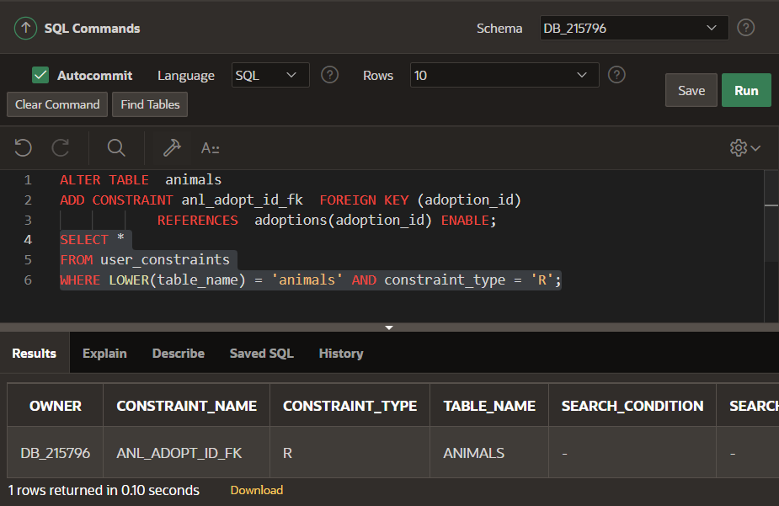

6. What is the effect of setting the foreign key in the ANIMAL table as:

b. ON DELETE SET NULL

a. ON DELETE CASCADE

7. What are the restrictions on defining a CHECK constraint?

- в нем нельзя вызывать детерминированные функции и функции, написанные пользователем

- условия ограничены полями и столбцами этой самой таблицы

- нельзя использовать подзапросы\